Infosys Springboard Virtual Internship 6.0 Completion Report
Batch Number: 2 BudgetWise AI based Expense Forecasting Tool
Start date : 13-08-2025
Names:
S.No | NAME
1 | GORLE AJAY
2 | EDUPULAPATI SAI PRANEETH
3 | GUMMADI CHANDANA
4 | GUNDAPU DIVYA SREE
5 | K.SRUJAN GOUD

Internship Duration: 8 Weeks

1. Project Title
BudgetWise AI based Expense Forecasting Tool

2. Project Objective

BudgetWise is an AI-powered expense forecasting solution that helps individuals and businesses manage their finances with greater precision and control. Using advanced machine learning models, it examines historical spending behavior and accurately predicts future expenses by accounting for income patterns, lifestyle habits, and seasonal variations. The platform delivers personalized budgeting suggestions and presents financial forecasts through intuitive dashboards and interactive visual reports. It also provides timely alerts and actionable insights to help users avoid overspending, while offering seamless integration with banking and financial applications for real-time data synchronization. As new transactions are recorded, the AI system continually learns and refines its predictions. With support for multiple user profiles, BudgetWise is suitable for individuals, families, and small businesses. Ultimately, it enables users to make informed financial decisions, enhance budgeting efficiency, and build stronger saving habits.

3. Project description in detail

BudgetWise is an advanced AI-driven expense forecasting platform designed to meet the rising demand for smarter financial management among individuals, families, and businesses. The system utilizes artificial intelligence (AI) and machine learning (ML) to examine historical spending records, detect recurring patterns, and generate reliable predictions for future expenses. Through intelligent insights and data-driven guidance, the tool enables users to plan budgets more efficiently, cut unnecessary costs, and strengthen long-term saving habits.
The platform operates by integrating with bank accounts, digital wallets, and financial services to collect real-time income and expenditure information. Using sophisticated algorithms, BudgetWise categorizes expenses into segments such as housing, food, transportation, healthcare, and entertainment. It then applies predictive modeling methods to forecast upcoming spending while accounting for lifestyle adjustments, seasonal fluctuations, and inflationary trends.
A key highlight of BudgetWise is its dynamic dashboard, which displays financial insights using clear charts, graphs, and visual summaries. The tool also offers personalized alerts and recommendations to inform users about overspending patterns, approaching bills, and potential saving opportunities. For businesses, the system can estimate operational expenses, employee-related costs, and cash-flow behavior, helping them make more strategic financial decisions.
Furthermore, BudgetWise accommodates multiple user profiles, making it effective for individuals, families handling shared budgets, and small-to-medium enterprises (SMEs). Its adaptive AI engine steadily enhances prediction accuracy as it processes additional data, evolving with user behavior and changing financial objectives.
Ultimately, the project aims to deliver a comprehensive digital financial assistant that not only forecasts expenses but also promotes better financial discipline. By merging predictive analytics with an intuitive interface, BudgetWise effectively connects technology with personal finance, guiding users toward stability and smarter decision-making in a rapidly data-driven environment.
4. Timeline Overview
Week | Activities Planned | Activities Completed
Week 1 | Requirement gathering, understanding user needs, defining modules (Expense, Budget, Dashboard, Forecasting, Recurring).  Selecting technologies: Python, Streamlit, SQLite, Gemini API, ML models. | Finalized project scope, feature list, and module flow.  Streamlit chosen for UI, SQLite for DB, and CatBoost/XGBoost/LightGBM for forecasting.  Repository setup completed.
Week 2 | System design: database schema, authentication workflow, UI wireframes, ML pipeline design. | Database tables created (users, expenses, budgets, recurring).  UI layout planned for each page.  ML preprocessing pipeline designed.
Week 3 | Data collection and preprocessing for ML model training.  Cleaning dataset and identifying categorical/numerical features. | Financial dataset collected and cleaned.  Handled missing data, dropped unnecessary columns, and prepared features for training.  Dataset validated with test samples.
Week 4 | Model development: Train CatBoost, XGBoost, LightGBM, and ensemble model.  Evaluate accuracy and classification performance. | All three models trained and tested.  Ensemble stacking implemented with high accuracy.  Generated plots: confusion matrix, classification report, feature importance.
Week 5 | Building the Streamlit UI for Dashboard, Expense, Budget, Recurring, and AI Forecast. | Developed all main UI pages.  Added interactive Plotly charts, spending summary, category-wise graphs, and transaction cards.  Implemented dark theme styling.
Week 6 | Backend development: CRUD operations, receipt uploads, CSV import/export, recurring automation, authentication.  Integrate ML model with UI. | Fully implemented expense CRUD, image uploads, recurring entry system, CSV upload/download.  Added SHA-256 password hashing for secure login/registration.  Integrated forecasting model into AI Expense Forecast page.
Week 7 | System integration, testing, deployment on Streamlit Cloud, preparing documentation and final demo. | Complete integration of UI + DB + ML + API.  Gemini API added for personalized financial advice.  Performed testing and resolved bugs.  Deployed final app and completed documentation + demo presentation.

5a. Key Milestones
Milestone | Description | Date Achieved
Project Kickoff | Defined the project objectives, identified key features like expense tracking, budgeting, AI forecasting, and finalized the overall development plan.
Prototype/First Draft | Built the initial prototype of the BudgetWise application, including basic UI pages, expense entry functionality, and early model training outputs..
Mid-Term Review | Demonstrated progress on ML model development, dashboard UI, authentication system, and recurring expenses; refined workflow based on mentor feedback.
Final Submission | Submitted the complete BudgetWise system with full features—including AI forecasting, receipt uploads, dashboards, authentication—and all required documentation.
Presentation | Delivered a final presentation showcasing the AI models, system architecture, Streamlit interface, financial insights, and overall project outcomes.

5b. Project execution details

• Requirement Analysis – Identified user needs for expense tracking, budgeting, forecasting, and financial insights; finalized project goals and feature list.
• Technology Selection – Chose Streamlit for the UI, SQLite for the database, Python for backend logic, Gemini API for AI-driven advice, and CatBoost, XGBoost, LightGBM, and Stacked Ensemble models for forecasting.
• System Design – Designed the database schema, authentication flow, expense workflow, dashboard layout, and overall user interface structure.
• Data Collection – Used real-world financial datasets and created synthetic expense records for training and application testing.
• Data Preprocessing – Cleaned data, handled categorical/numerical features, removed missing values, and prepared the dataset for ML model training.
• Model Development – Trained CatBoost, XGBoost, LightGBM, and an ensemble stacking model; performed hyperparameter tuning; achieved high prediction accuracy.
• AI Integration – Implemented AI-based expense forecasting and integrated Gemini Pro API for personalized financial advice.
• Frontend Development – Built interactive dashboards, visual charts, summary cards, budget tracking UI, recurring expense pages, and an intuitive dark-themed interface using Streamlit.
• Backend Development – Implemented CRUD operations for expenses, receipts upload handling, CSV import/export, authentication using SHA-256, and recurring expense automation.
• Testing & Integration – Conducted module testing, database testing, model evaluation, UI/UX testing, and resolved integration issues between ML models and the app.
• Deployment & Documentation – Deployed the app on Streamlit Cloud, prepared technical documentation, wrote the README, and delivered the final project demo.

6. Snapshots / Screenshots
Step 1 : To access the project, simply go to the GitHub repository. In the README file, you will find the website link for BudgetWise. Just click on that link to open the live application
https://github.com/SaiPraneeth-E/BudgetWise-AI/
Step 2 : The link will look like this: https://budgetwise-ai.streamlit.app/
Step 3 : After clicking the link, the BudgetWise website opens, and the first page you see is the Login and Register screen.
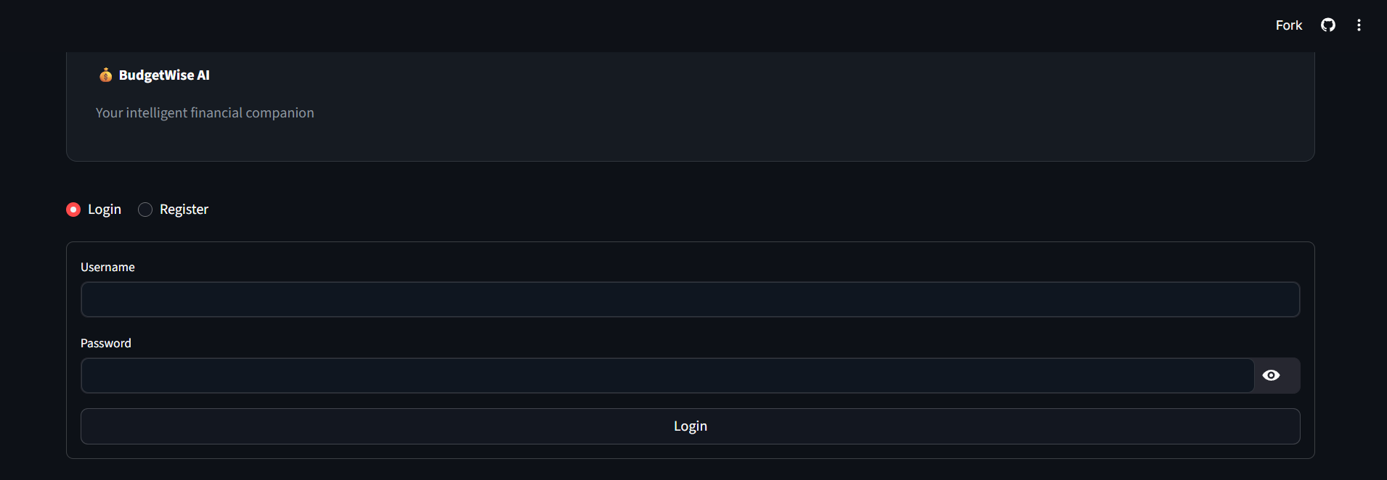

Step 4: After clicking on Login here user need to register and log in for Authentication.
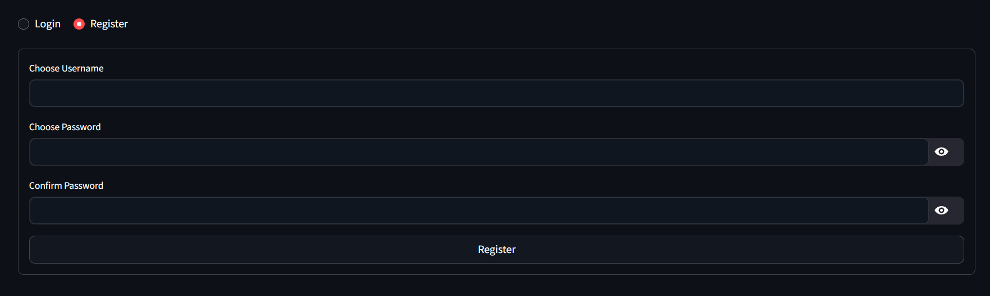
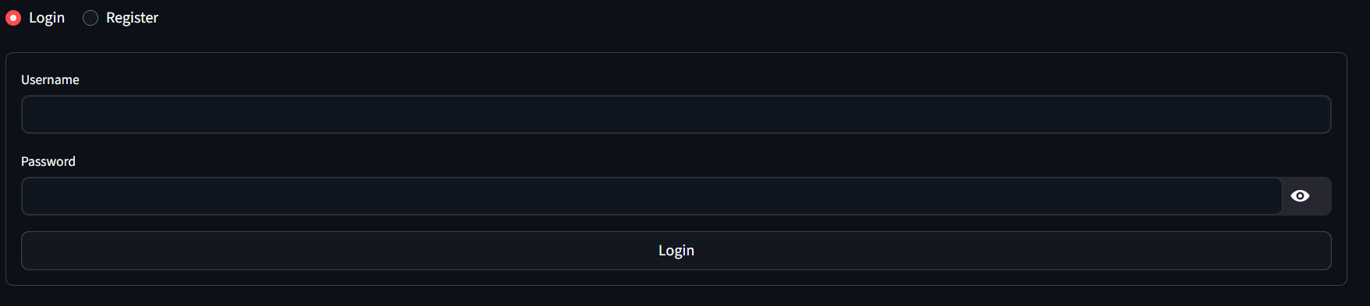
Step 5: Once you log in, the website dashboard appears, and the interface looks like this.
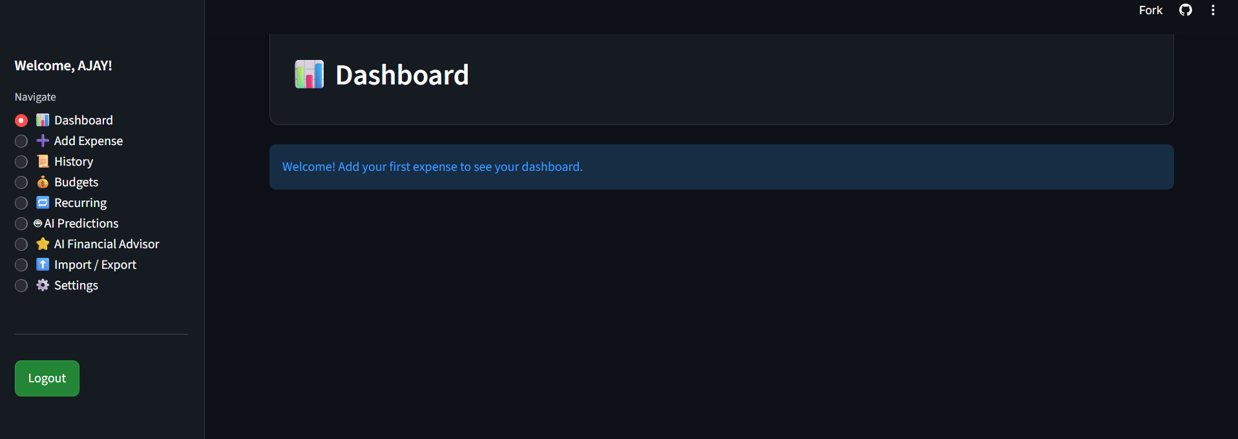

Step 6: Next, we need to open the Expense page and add our expenses.
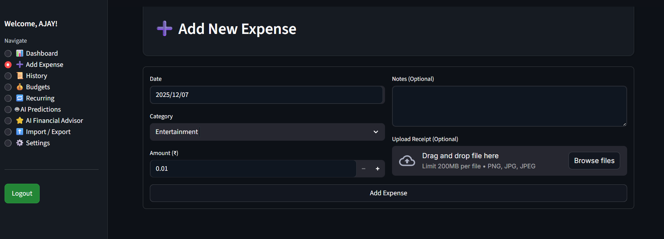

Step 7: On the Expense page, we can add an expense for a specific date, and we also have the option to include notes. We can choose a category such as Entertainment, Food, Shopping, and more. Additionally, we can upload receipts or bills if needed, but this is completely optional
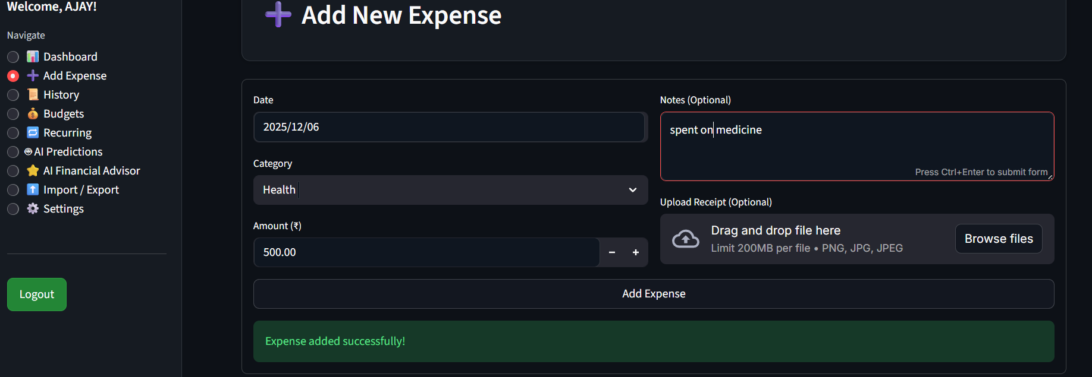

Step 8: Next, we can view all the added expenses on the History page. Here, we can filter the expenses by category or date, and we also have the option to delete any expense if needed.
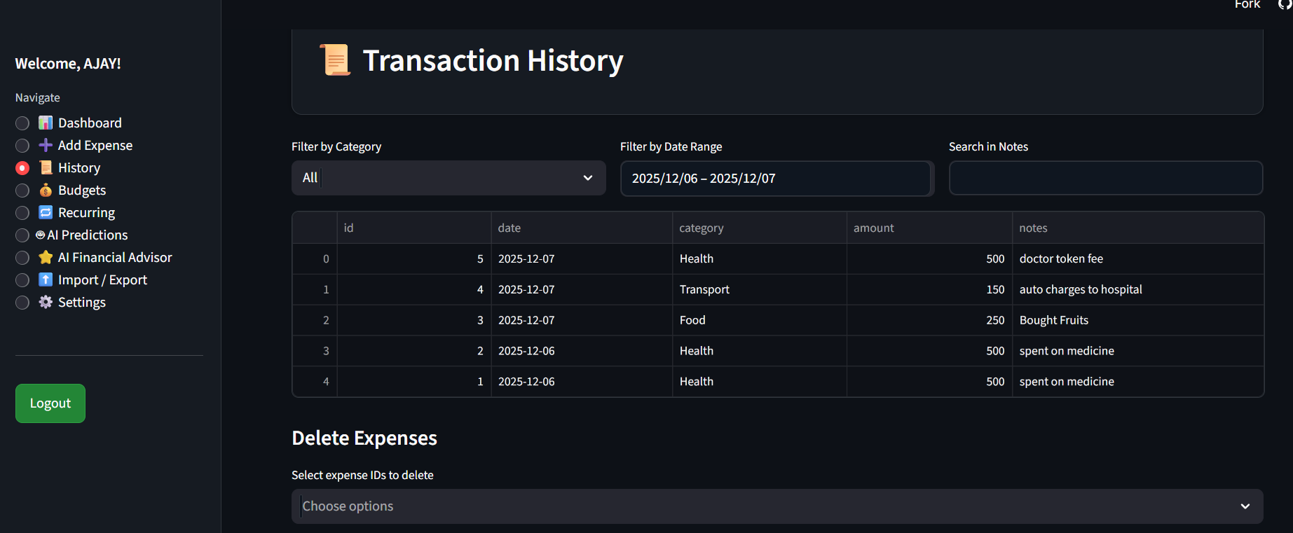

Step 9: In the Dashboard page, we can view the total amount spent, the number of transactions, and the average daily spending. We can also see visual insights such as plots and graphs that represent our spending patterns
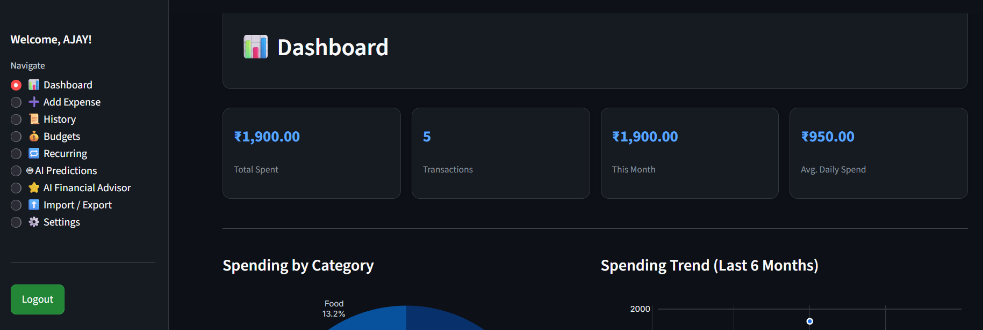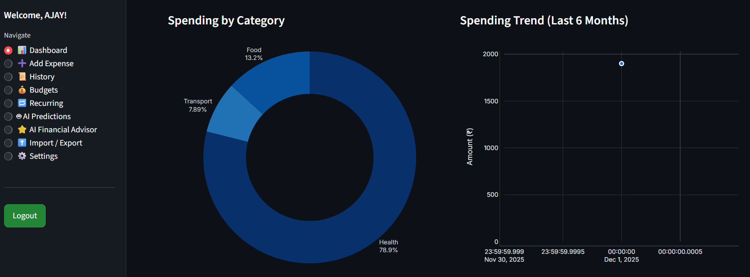
Step 10: In the Budget tab, we can set custom budgets for different categories to manage our spending more effectively
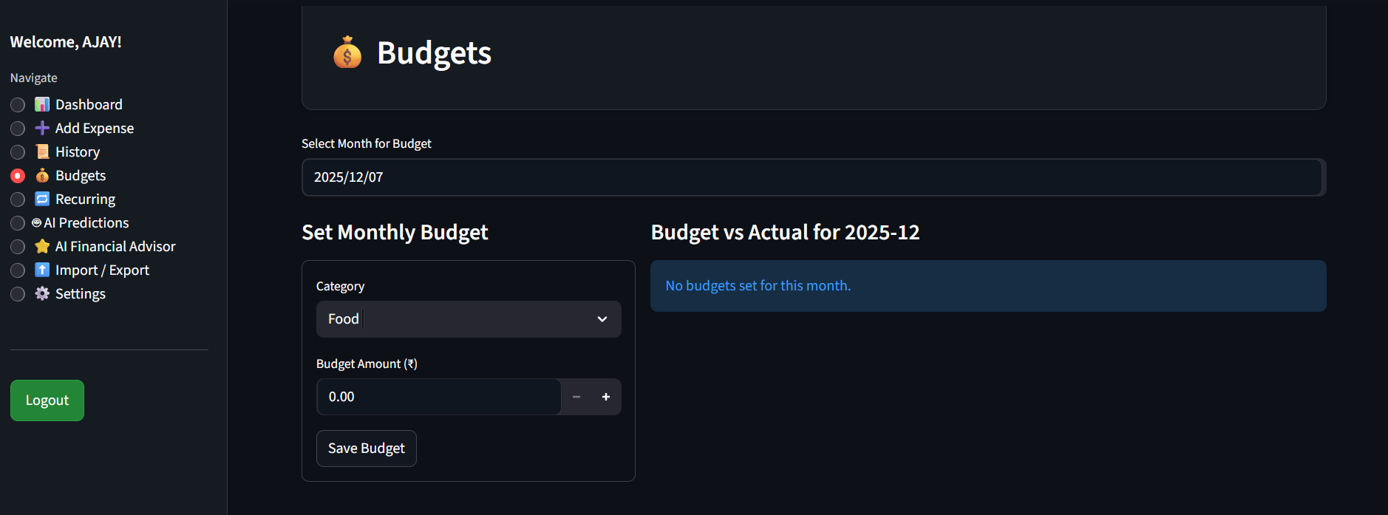

Step 11: In the Recurring tab, we can add recurring expenses such as house rent or water bills, and these will be added automatically at the specified intervals.
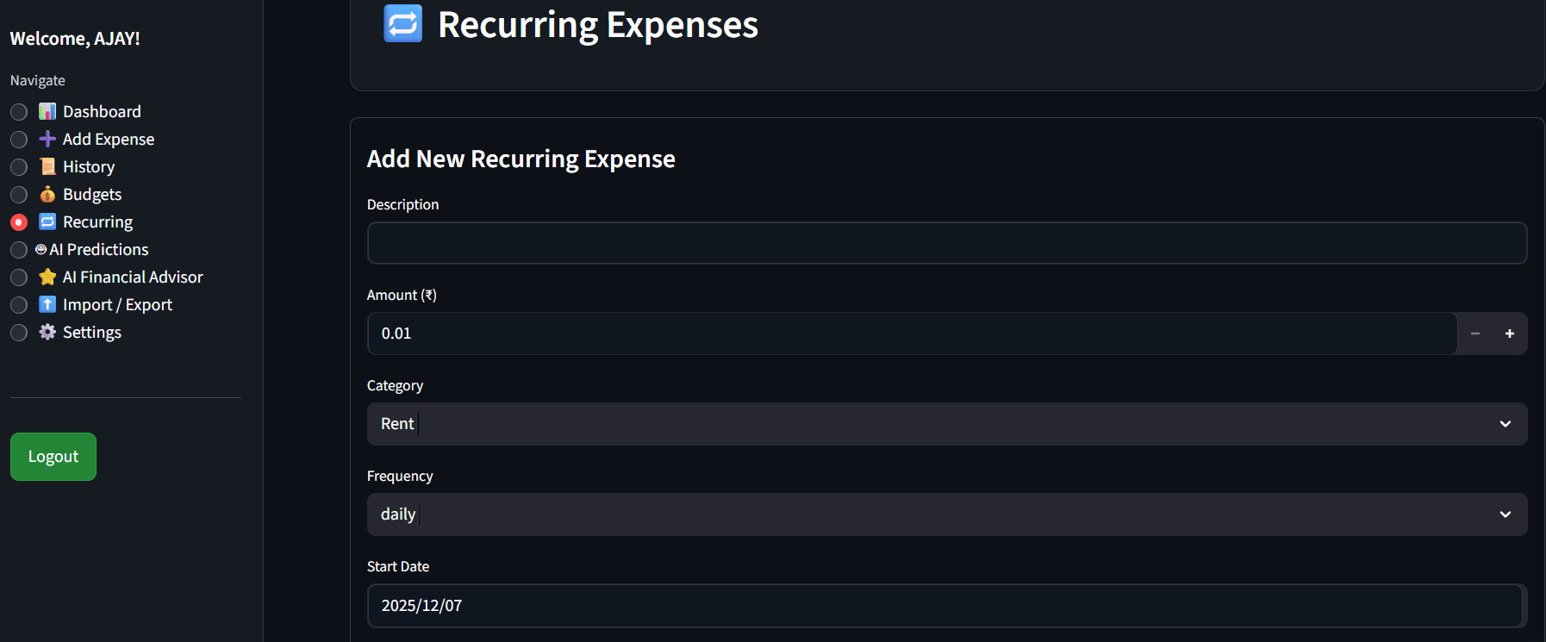

Step 12: The AI Expense Forecast feature allows us to generate spending predictions for selected categories
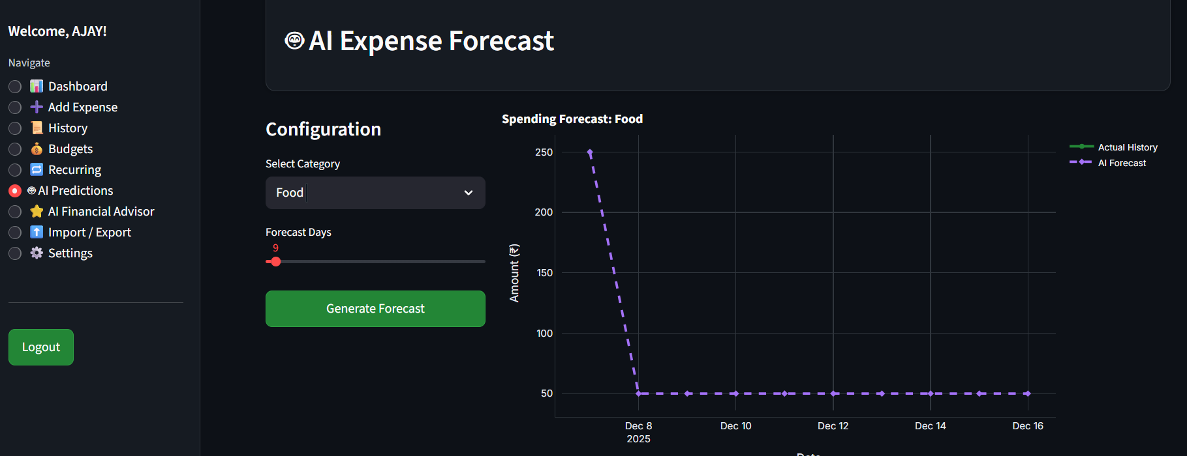

Step 13: Finally, we can download all our expense data in CSV format, and we also have the option to upload expenses using a CSV file
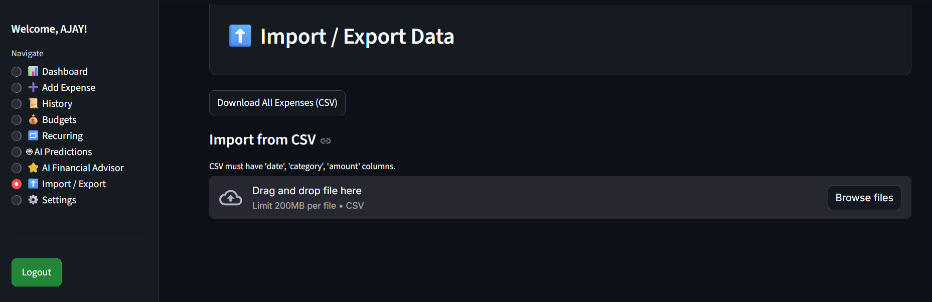

7. Challenges Faced

Preparing the dataset was difficult because it had both missing values and unnecessary columns.
Handling categorical and numerical features differently for each model was challenging.
Creating separate preprocessing pipelines for CatBoost, XGBoost, and LightGBM took extra effort.
Tuning hyperparameters to reach above 95% accuracy required a lot of experimentation.
Building the stacking ensemble model without causing overfitting was a major challenge.
Integrating the ML model into Streamlit while keeping the app fast was not easy.
Implementing secure authentication with SHA-256 hashing required careful coding.
Managing receipt image uploads and storing them properly in the database was challenging.
Designing a clean UI in Streamlit for multiple pages and charts required proper layout planning.
Adding CSV upload/download features needed extra validation to avoid bad or corrupt files.
Connecting with the Gemini API sometimes caused delays and required error handling.
Optimizing the SQLite database to avoid slow queries and locked states was difficult.
Maintaining everything in a single-file Streamlit app made organization and debugging harder.

8. Learnings & Skills Acquired

Gained strong understanding of data cleaning and preprocessing techniques for real-world datasets.
Learned how to handle categorical and numerical features using different encoding methods.
Improved skills in training ML models like CatBoost, XGBoost, and LightGBM.
Understood hyperparameter tuning to improve model accuracy and performance.
Learned to build a stacking ensemble model for maximum prediction accuracy.
Gained experience in saving and loading ML models using joblib for deployment.
Developed backend integration skills by connecting the ML model with Streamlit.
Learned to design a user-friendly UI with Streamlit and Plotly visualizations.
Improved database management skills using SQLite for CRUD operations.
Learned secure authentication implementation using SHA-256 hashing.
Gained experience in handling file uploads like receipts and CSV files.
Understood how to generate interactive charts using Plotly and Seaborn.
Developed API integration skills by connecting the app with Gemini Pro for AI advice.
Learned clean project structuring and debugging in a multi-feature Streamlit application.
Improved problem-solving skills by addressing real-world financial tracking and forecasting challenges.

9. Testimonials from team
Team Member 1:
" Working on BudgetWise AI taught me how powerful machine learning can be when combined with real-world financial data. I gained strong experience in model training, tuning, and deploying AI systems, and this project boosted my confidence in building end-to-end intelligent applications."

Team Member 2:
" This project helped me improve my skills in backend development and database management. Implementing authentication, handling receipts, and building a smooth user experience taught me how to create secure and scalable financial applications."

Team Member 3:
" Developing the UI and dashboard for BudgetWise AI was a great learning journey. Working with Streamlit and Plotly helped me understand how to design clean, interactive interfaces that make data easier for users to understand."

Team Member 4:
" One of my biggest learnings was integrating APIs into live applications. Connecting Gemini Pro for intelligent financial advice gave me hands-on experience in working with external AI services and ensuring smooth communication between the app and the API."

Team Member 5:
“I focused on testing, debugging, and improving the overall workflow of the project. This experience strengthened my problem-solving skills and taught me how to identify performance issues, fix errors, and ensure the application works reliably for users.”

10. Conclusion.

The BudgetWise project successfully delivered a fully functional, AI-powered personal finance management system that integrates machine learning, secure authentication, database management, and an intuitive user interface into one cohesive application. By combining advanced models such as CatBoost, XGBoost, LightGBM, and a stacked ensemble, the system achieves highly accurate expense predictions, enabling users to plan their budgets with confidence. The Streamlit-based platform provides seamless expense tracking, budgeting tools, recurring expense automation, CSV import/export, receipt uploads, and AI-driven financial insights powered by the Gemini API.
Throughout this project, we not only built a robust and user-friendly financial solution but also strengthened our skills in end-to-end ML pipelines, data preprocessing, model deployment, UI/UX development, and secure system design. The project enhanced our teamwork, technical problem-solving, and understanding of real-world financial analytics. Overall, BudgetWise demonstrates how AI and modern software technologies can be combined to simplify financial decision-making and empower users to develop healthier financial habits.

11. Acknowledgements

I would like to extend my heartfelt gratitude to Infosys for giving me the invaluable opportunity to work on the BudgetWise AI-based Expense Forecasting Tool during my internship. This project allowed me to gain practical experience in artificial intelligence, machine learning, and real-world application development, which greatly enriched my technical skills.
I am deeply thankful to my mentor, Sangeetha, for her continuous guidance, encouragement, and expert insights throughout the internship. Her support played a crucial role in helping me overcome challenges and grow both professionally and personally.
I would also like to express my appreciation to my team members for their excellent teamwork, collaboration, and dedication. Their support and cooperation made the entire project journey productive and enjoyable.
Finally, I thank everyone who contributed directly or indirectly to the successful completion of this project and to my overall learning experience.

